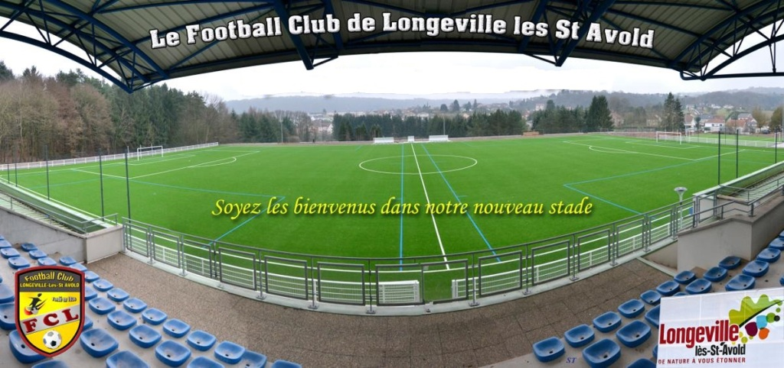

Site du tournoi : http://fair-play-young-cup.footeo.com/
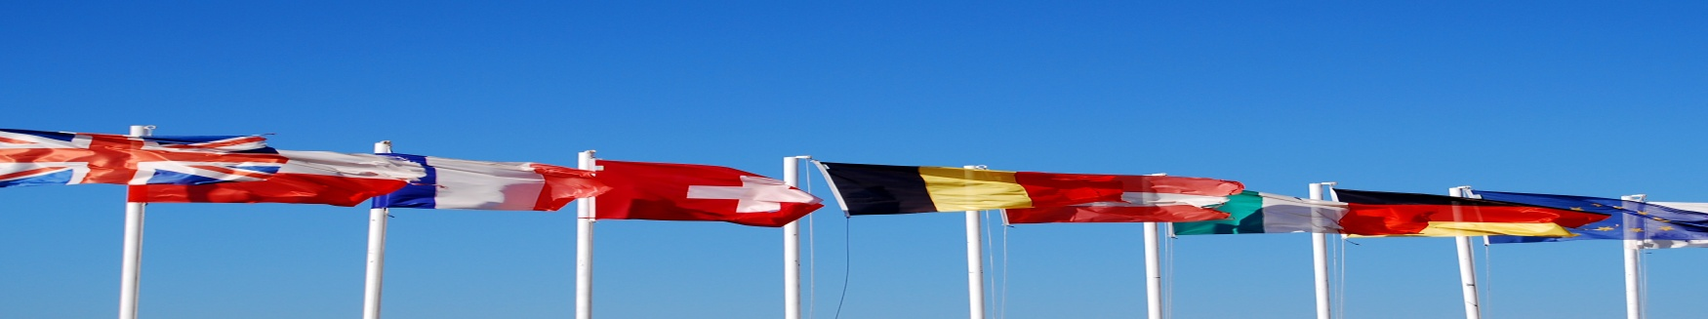
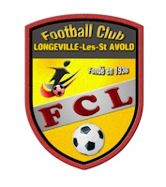
FC Longeville les Saint - Avold (Moselle.FR) is organizing the U11 International Fair Play Young Cup on June 9 and 10, 2018.
Come and participate in the unmissable event in the East of France with the best football schools from Germany, Luxembourg, Belgium and different French regions.
On a site of very high quality, this tournament that is both friendly, friendly and excellent football quality will no doubt an end of the season unforgettable for your young talents but also for all accompanying.
The participation fee is FREE
All teams will be rewarded and the most Fair-play team of the tournament will be awarded a prize for each player on the team.
Animations and restorations on the spot.
Tournament website: http://fair-play-young-cup.footeo.com/

Club name:

Number of team:

Team leader:

Mail address :

Tel:

Region: Department:

Number of players (max 12 / teams):

Document to return:
ZILVAR Guy
3a rue d'Alsace
57890 Diesen
Tel: 00336 31 61 55 17
Mail: fair-play.young-cup@orange.fr
Tournement web site: http://fair-play-young-cup.footeo.com/

